**Recipe: Three Babes Bakeshop Peach Raspberry Almond Streusel Pie**

July 14, 2015, Updated: June 26, 2017

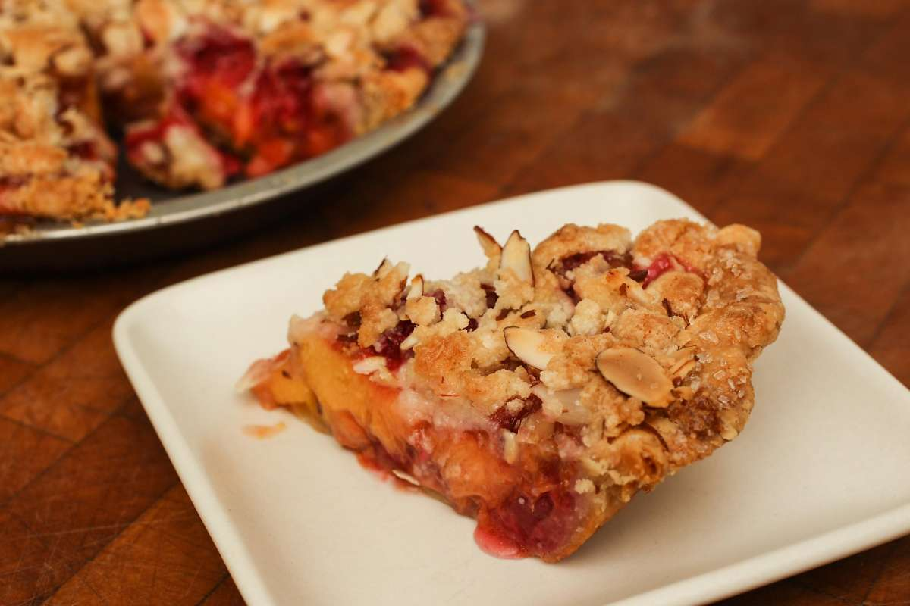

A slice of peach raspberry pie with almond streusel topping is seen in Amy Machnak's San Francisco home Friday, June 5, 2015.Loren Elliott/The Chronicle

Three Babes Bakeshop Peach Raspberry Almond Streusel Pie

*Makes 1 pie; serves 8-10*

Pie dough

 1 stick + 1 tablespoon unsalted butter, cut into 1/2-inch cubes

1/3 cup ice water

11/2 teaspoons apple cider vinegar

11/2 teaspoons sugar

1/2 teaspoon kosher salt

11/2 cups all-purpose flour

Almond streusel topping

 1/2 cup powdered sugar

1/2 cup all-purpose flour

1/2 teaspoon baking powder

1 teaspoon kosher salt

8 tablespoons (1 stick) unsalted butter, softened

1/2 cup sliced almonds

Peach-raspberry filling

 1/4 cup packed brown sugar

1/2 cup granulated cane sugar

1/4 cup cornstarch

1/2 teaspoon kosher salt

1 teaspoon grated fresh lemon zest

1 teaspoon fresh lemon juice

2 pounds ripe peaches, halved, pitted and sliced 1/2-inch thick

1 basket (pint) raspberries

Cream; or an egg yolk mixed with water, for brushing

Coarse sugar, for sprinkling

Make the crust: Put the butter in a medium bowl and put in the freezer. Combine the water, vinegar, sugar and salt until dissolved, and place in the freezer to chill until very cold, about 15 minutes.

Add the flour to butter; using a pastry cutter or your fingers, cut or break up the butter into the flour until the mixture resembles coarse meal.

Sprinkle the flour and butter with the water mixture, a little at a time, mixing as you add the liquid so that all dry dough becomes moistened, until the dough just comes together. Turn the dough out onto a work surface, form into a disk, wrap with plastic and chill at least 1 hour or up to 2 days.

Roll out the dough on a lightly floured work surface to about 12 inches in diameter. Transfer the dough into a greased pie plate (metal or glass, but not ceramic). Trim the excess dough so the overhang barely touches the counter. Refrigerate about 30 minutes.

Remove the shell from the refrigerator, and roll the edge of the bottom crust under tightly, forming a rope that rests comfortably on the rim of the pie plate. Press the edge between two knuckles of one hand and the thumb of the other to flute. Put in the freezer to freeze solid, about 30 minutes or up to 2 days.

Preheat the oven to 375 degrees. Line the frozen pie shell with aluminum foil or parchment paper, and fill with dried beans or pie weights. Bake 20 minutes, until the crust is begins to brown slightly. Remove from the oven and let cool completely.

Make the streusel: Combine all the ingredients, except the almonds, with a rubber spatula, until the mixture resembles crumbly cookie dough. Add the almonds and mix to combine; set aside.

Make the filling: Preheat the oven to 350 degrees with the rack set at the lower third of the oven. Mix the sugars, cornstarch, salt, lemon zest and juice. Add the peaches and raspberries, tossing gently to coat.

Immediately add the fruit filling to the pre-baked pie shell. Top with the almond streusel, sprinkling on a little at a time and covering the whole pie evenly. Brush the outer edge of the crust with cream or egg wash, and sprinkle with coarse sugar.

Bake the pie: Place the pie on a parchment-lined baking pan. Bake about 11/4 hours, until the fruit starts to bubble around the sides. Transfer the pie to a wire rack and let cool to room temperature before serving.

Per serving: 399 calories, 4 g protein, 54 g carbohydrates, 20 g fat (12 g saturated), 53 mg cholesterol, 347 mg sodium, 4 g fiber.

https://www.sfchronicle.com/cooking/article/Recipe-Three-Babes-Bakeshop-Peach-Raspberry-6383920.php